

Student Intelligent Productivity Scheduler

  - School of Computer Science and Maths
  - LJMU
  - Student: Arwa Daaboul
  - Supervisor: Dr Hoshang Kolivand

Abstract

Chapter 1:
Introduction

1.1 Introduction

In the contemporary higher education landscape, students face unprecedented levels of pressure to excel academically while managing their personal well-being. This intense environment often leads to significant challenges, including burnout and academic stress, with one study finding that nearly a third of students exhibit depressive symptoms (Yan Liu, 2018), ), and in the UK, a recent survey by Student Minds (2023) found that 57% of students reported their mental health had declined since starting university. To prevent that, effective time management is widely promoted to cope with this stress. Research shows that techniques like planning and scheduling improve a student's 'Perceived Control over Time (PCT)', which in turn has a positive effect on their academic performance, productivity, and well-being (Alhasani, 2024).
In response, a significant market of digital productivity tools has emerged, designed to help students manage their schedules. However, these tools are often limited to basic task management and fail to provide the tailored, adaptive support that students need (Roffarello & De Russis, 2019). This "one-size-fits-all" approach is insufficient because it fails to address the underlying realities of modern student life, particularly the pervasive issue of digital distraction. Research confirms that high social media usage is negatively associated with academic performance (Masood, Jurcut & Rusu, 2021), highlighting a critical gap for a tool that can actively help students manage this specific challenge.
This highlights a critical gap for a new class of scheduler that is not just a static digital calendar, but an intelligent and adaptive productivity partner. The future of student productivity tools lies in leveraging AI and machine learning to provide personalised, proactive support. As suggested by recent research, these systems can learn from a user's patterns of task completion to offer strategic guidance that helps mitigate procrastination tendencies and support student well-being (Alhasani, 2024).
The motivation for this project stems from the opportunity to apply modern machine learning techniques to create a system that understands and adapts to a student's unique daily condition, considering the student’s sleep, mental health, social media usage, and other commitments, to foster a healthier and more effective approach to studying.

1.2 Problem Statement

Current schedulers are not equipped to handle scheduling around a student's fluctuating ability to focus. These tools operate on the flawed assumption that all hours of the day are equal, ignoring the dynamic internal and external factors that impact cognitive performance. Students nowadays exhibit moderate to poor sleep quality and face mental health challenges, with many digital distractions acting as a barrier to their cognitive focus. This challenge is confirmed by research which reveals that students are in urgent need for solutions addressing their sleep hygiene, mental health, and digital behaviours to improve their academic performance (Sharma, 2025). However, a significant gap exists in the availability of practical, automated tools designed to provide this support.
A student's ability to perform deep work is influenced by several measurable variables. This project will investigate the predictive power of key lifestyle factors, including the number of hours they have slept, their mental health rating, and the hours they spend on distractions. For example, insufficient sleep has been shown to impair critical cognitive functions such as attention and memory consolidation, while high stress levels can disrupt executive function and make complex problem-solving more difficult (National Institute of Neurological Disorders and Stroke, 2023).
This mismatch between a student's assigned tasks and their actual cognitive state leads to inefficiency, frustration, and can contribute to academic burnout. Therefore, a significant problem exists: there is no intelligent system that can automatically ingest these dynamic, user-specific variables to predict an individual's focus state and schedule tasks accordingly.

1.3 Aim
The aim of this project is to design, implement, and evaluate an intelligent scheduler that uses a machine learning model to predict a student's focus level and generate an optimised daily schedule.

1.4 Objectives

- To investigate existing literature on student productivity and distractions, personalised scheduling algorithms, and the application of machine learning for user behaviour prediction.
- To design the intelligent scheduler prototype, outlining its system architecture, user interface concepts, the required data features for the predictive model, and the integration strategy.
- To develop and train a predictive machine learning model by processing a public dataset to engineer a 'Focus_Level' target variable and using this data to predict a student's daily focus.
- To implement a functional prototype/web application that integrates the predictive model to generate an optimised daily schedule based on a user's tasks.
- To evaluate the results of the application by assessing the model’s technical performance and validating its practical utility with a custom-collected dataset.

1.5 Contribution
1.6 Scope
1.7 Structure of thesis

Chapter 2:
Literature Review

2.1 Introduction
The modern university experience is defined by an increasing demand for academic excellence balanced against a backdrop of declining student mental health. As highlighted in Chapter 1, the prevalence of burnout and depressive symptoms among students is rising (Liu, 2018), often exacerbated by poor lifestyle habits and the 'always-on' culture of the digital age."
In an attempt to navigate this pressure, students often turn to digital productivity tools. However, current literature suggests a disconnect between traditional time management advice, which focuses on static scheduling, and the biological reality of the student experience. Factors such as sleep hygiene, stress levels, and digital distraction play a pivotal role in cognitive readiness, yet they are rarely accounted for in standard scheduling algorithms.
Consequently, this literature review is structured to explore three critical domains. First, it examines the psychological and physiological determinants of focus (Section 2.2), specifically analysing the impact of sleep and stress. Secondly, it critiques existing technological interventions (Section 2.3), identifying the limitations of current static schedulers. Finally, it reviews the application of Machine Learning in user behaviour modelling (Section 2.4), establishing the theoretical basis for an intelligent, adaptive scheduler.

2.2. Search Methodology
The literature search was conducted between December 2025 and February 2026. Primary databases included IEEE Xplore, ACM Digital Library, and Google Scholar to ensure a multidisciplinary approach covering both Computer Science and Behavioural Psychology.
Inclusion Criteria:
- Peer-reviewed journals and conference papers.
- Studies published between 2018–2026 (prioritizing the last 5 years).
- Research focusing on higher education students.
Keywords used: Machine Learning in Education, Student Productivity, Random Forest Classification, Sleep Hygiene, Cognitive Readiness. MORE HERE?

2.3 The Psychology of Student Productivity
- 2.3.1 Cognitive Readiness & Mental Health
To understand student productivity, one must first define the cognitive mechanisms required for academic work. The primary driver of study performance is Executive Function—a set of mental skills controlled by the prefrontal cortex that includes working memory, flexible thinking, and self-control. For a student to engage in 'Deep Work,' their executive function must be operating optimally, allowing them to filter out distractions and sustain attention on complex tasks.
However, mental health struggles, particularly anxiety and high stress, act as a direct inhibitor to this system. Research in cognitive neuroscience demonstrates that high levels of cortisol (the stress hormone) impair the prefrontal cortex. This is often described as a 'neural hijack,' where the brain shifts resources from the logical centres (needed for studying) to the emotional centres (needed for survival/worry). Consequently, a student experiencing high anxiety does not merely lack motivation; they are experiencing a physiological reduction in their cognitive capacity and working memory.
In the context of higher education, this creates a 'vicious cycle' of productivity loss.
When a student is stressed, their executive function dips, leading to procrastination or inefficient studying. This lack of progress generates guilt and anxiety, which further suppresses executive function. Traditional, static schedulers fail to address this cycle because they continue to assign demanding tasks to a user who is physiologically incapable of performing them, inevitably leading to failure and burnout.
However, the relationship between stress and cognitive function is not entirely linear. A recent longitudinal study by Ma et al. (2025) utilized network analysis to deconstruct academic stress into specific subtypes. Their findings revealed a complex dynamic: while stress originating from external pressures exerted a significant negative effect on working memory updating and response inhibition, 'self-imposed stress' actually demonstrated a positive predictive effect on working memory span. This suggests that internalised motivation (eustress) can enhance executive function, whereas external anxiety tends to degrade it. This distinction is critical for the design of an intelligent scheduler; the system must aim to support the student's internal drive (self-imposed goals) while mitigating the cognitive load caused by external anxieties.
In addition to these external pressures, the subjective experience of time plays a crucial role in cognitive maintenance. Sussman and Sekuler (2022) demonstrated that 'Perceived Time Pressure' (PTP), the feeling of being rushed even in the absence of strict deadlines, acts as a significant stressor that degrades executive function. Their study found that increasing PTP diminished cognitive inhibition, making participants more susceptible to distractions and negative affect. This finding is particularly relevant for the design of scheduling algorithms; a system that packs tasks too densely may inadvertently increase PTP, thereby lowering the user's ability to focus. An intelligent scheduler, therefore, must not only allocate time for work but also strategically manage the intervals between tasks to minimize PTP and restore cognitive resources.
- 2.3.2 Sleep Hygiene
A divergence exists in the literature regarding the relationship between sleep and academic performance. While some studies (Eliasson et al., 2010; Sweileh et al., 2011) argue that sleep duration alone does not directly predict academic success, there is a broader consensus on the cognitive impact of sleep deprivation. Regardless of final grades, lack of sleep has been consistently shown to impair the foundational skills required for learning, specifically concentration, cognitive processing, and memory consolidation (Dewald et al., 2010; Jalali et al., 2020).
https://pmc.ncbi.nlm.nih.gov/articles/PMC7381801/

This relationship becomes particularly pronounced when students are under pressure. The impact of sleep is most critical during periods of high academic demand, such as exam seasons. A recent study by Suardiaz-Muro et al. (2023) found that during these intense periods, university students consistently exhibit insufficient and poor-quality sleep, which negatively correlates with their Academic Performance (AP). Interestingly, there is a high level of self-awareness regarding this issue among the student population. The study revealed that 61.3% of participants affirmatively acknowledged the influence of sleep on their grades, with approximately two-thirds believing their performance would improve if they could simply obtain more sleep. This highlights a clear gap: students are aware of the biological necessity of sleep, but lack the tools or strategies to maintain it during high-stress periods.
https://link.springer.com/article/10.1007/s41105-023-00457-1

- 2.3.3 The Attention Economy
The mechanism by which digital media impacts productivity is often through the diversion of cognitive resources. In a comprehensive study of social media habits, Gordon and Ohannessian (2024) found a consistent negative association between the frequency of use across four major platforms (Facebook, Twitter, Instagram, and Snapchat) and academic achievement.
Crucially, the authors argue that this decline is not merely a correlation, but a result of attention displacement: 'attention that would otherwise be invested in schoolwork is diverted to social media use' (Gordon & Ohannessian, 2024). This distraction is particularly potent on newer, visually-driven platforms like Instagram and Snapchat, which the study found were the most widely used among younger cohorts. This suggests that modern students are constantly battling an environment where their cognitive focus is being actively harvested by these applications, leaving them with a deficit of attention for deep academic work.
Furthermore, this impact is not uniform across all demographics. Gordon and Ohannessian (2024) noted that girls reported significantly more frequent use of Instagram and Snapchat than boys, suggesting that female students may be disproportionately affected by the specific distraction mechanics of visual-based platforms. Similarly, significant variations were found in platform preference across racial groups, with Hispanic adolescents reporting higher Facebook usage. This complexity implies that a 'one-size-fits-all' productivity tool may fail, because different student demographics engage with digital distractions in fundamentally different ways.
The cost of the attention economy extends beyond mere time management; it appears to exact a physiological toll on the user. Chen et al. (2025) investigated the neurobiological markers of digital engagement, specifically focusing on mobile gaming. Using Heart Rate Variability (HRV) analysis, they found that high-frequency users exhibited a state of chronic physiological arousal and significantly reduced inhibitory control. These students performed poorly on executive function tasks (such as the Stroop test), demonstrating a diminished capacity to filter out irrelevant stimuli. This provides biological evidence that digital distractions do not just occupy attention; they actively degrade the neural mechanisms required for self-regulation, making it increasingly difficult for students to 'switch off' and engage in deep work.

2.4 Existing Technological Interventions
- 2.4.1 Static Scheduling Tools
- 2.4.2 Persuasive Technology

- 2.4.3 Limitations of Current Solutions
The primary limitation of existing digital interventions is their 'algorithmic rigidity.' Most productivity applications operate on the assumption of a static user state—treating a Monday morning and a Friday evening as cognitively identical. They fail to account for the 'biological tax' of poor sleep or high cortisol levels. Consequently, when a student is in a low-focus state, these apps continue to push high-intensity tasks, leading to the 'Perceived Time Pressure' identified by Sussman and Sekuler (2022). There is a clear research gap for a system that dynamically recalibrates its scheduling logic based on the user's physiological readiness.
2.5 Machine Learning in User Behaviour Modelling
- 2.5.1 Predicting User States
The application of Machine Learning (ML) in education is primarily concentrated within the field of Educational Data Mining (EDM). Historically, EDM has focused on predicting long-term academic outcomes, such as final grades or dropout rates. However, a recent shift in the field aims to predict dynamic user states, such as real-time engagement or cognitive readiness. For an intelligent scheduler, the technical challenge is a Classification Problem: the system must take input variables (sleep, stress, distraction) and classify the user’s current state into a specific category (e.g., 'High Focus' vs. 'Low Focus').
One of the most foundational algorithms used in this domain is the Decision Tree. As defined by [Insert Ref 1], a Decision Tree operates as a hierarchical flowchart, where internal nodes represent tests on an attribute (e.g., 'Is sleep < 6 hours?'), and leaf nodes represent the final class label ('Low Focus'). This algorithm is particularly favoured in educational contexts due to its interpretability—it is easy to visualize exactly why the model made a specific prediction, which is crucial for building trust with student users.
However, single Decision Trees can be prone to overfitting, where the model memorises the training data rather than learning general patterns. To mitigate this, this project proposes the use of a Random Forest algorithm. Random Forest is an 'ensemble' method that constructs multiple decision trees and merges them together to get a more accurate and stable prediction (the 'majority vote' method). Research by [Insert Ref 2] suggests that Random Forest classifiers typically outperform single trees when dealing with the complex, noisy data associated with human behaviour.
In the domain of Learning Analytics (LA), predicting a student's cognitive state is traditionally treated as a classification problem. The technical objective is to map a set of input features—such as sleep duration, stress levels, and digital engagement—to a target 'label' representing the student's focus or readiness to study.
A landmark systematic review by Pitchapati and Moraes (2025) evaluated the landscape of ML algorithms for student performance. Their findings indicate that while Deep Learning (DL) models (like LSTM or CNN) often achieve the highest raw accuracy (exceeding 90%), they act as "black boxes" with high computational costs, making them difficult to implement in real-time student tools.
In contrast, Random Forest (RF) emerged as the most balanced and "versatile choice" (Pitchapati & Moraes, 2025). The study highlighted that RF achieved an average accuracy of approximately 88.7%, offering a critical advantage in interpretability. Unlike single Decision Trees, which are prone to "overfitting" (memorizing the noise in the data), the RF operates as an ensemble method. By constructing multiple decision trees and utilizing a "majority vote" system for the final classification, the model provides a more stable and robust prediction even when student data is "noisy" or imbalanced.
For the purpose of the Intelligent Scheduler, RF is selected as the primary algorithm. This choice is justified by its ability to handle non-linear relationships between physiological stressors (like cortisol/stress) and focus outcomes, without requiring the massive datasets or processing power demanded by DL.

P. R. Pitchapati and M. Moraes, "Machine Learning Algorithms for Student Performance Prediction: A Literature Review," 2025 IEEE Frontiers in Education Conference (FIE), Nashville, TN, USA, 2025, pp. 1-8, doi: 10.1109/FIE63693.2025.11328262. keywords: {Measurement;Accuracy;Machine learning algorithms;Computational modeling;Scalability;Linear regression;Predictive models;Prediction algorithms;Random forests;Systematic literature review;Higher Education;Computer Science;Academic Advising},

- 2.5.2 Personalised Scheduling Algorithms

2.5.2 Personalised Scheduling Algorithms The transition from predicting focus to generating an actionable schedule involves solving complex Constraint Satisfaction Problems (CSPs). Kalachova and Salo (2020) emphasize that in an "Adaptive Educational System," the schedule must not be a rigid timeline, but a flexible model that accounts for the "stochastic nature" of student life.

Recent advancements by Yan and Deng (2025) explore the use of Adaptive Genetic Algorithms to solve scheduling conflicts in educational settings. While their work focuses on course scheduling, the underlying logic is highly applicable to individual student productivity. Genetic Algorithms mimic the process of natural selection to find the "fittest" schedule—one that maximizes productivity while minimizing stress and "time-clashes." By integrating these optimization methods, a scheduler can dynamically reorganize a student's day when their "Focus Score" (predicted by RF) drops unexpectedly. This creates a "Self-Healing" calendar that responds to the biological and environmental informatisation of the modern student (Yan & Deng, 2025).

A more immediate solution in the literature involves Heuristic-Driven Allocation. This involves weighting tasks based on their "Cognitive Load" (e.g., 'Writing a Dissertation' vs. 'Checking Emails'). An intelligent scheduler uses the RF output to "gatekeep" these tasks. If the model predicts a 'Low Focus' state, the heuristic algorithm pushes the high-load tasks to a later window where the predicted focus is higher. This creates a "Fluid Calendar" that adapts to the student's biological reality, rather than forcing the student to adapt to a rigid, static plan.

Kalachova, V. and Salo, N., 2020. Models and methods of preparing effective schedule in adaptive educational system. MODERN PROBLEMS OF COMPUTER SCIENCE AND IT-EDUCATION, 1, p.208.
Yan, L. and Deng, H., 2025. Adaptive Genetic Algorithm for Computer Course Scheduling System Under the Background of Educational Informatization. Systems and Soft Computing, p.200324.2.6 Discussion

Discussion
- Synthesis
- Table 2.2: Comparative Analysis (Pros & Cons of Static vs. Persuasive vs. Intelligent Schedulers).
- The Research Gap
2.7 Conclusion
- Summary of key findings.
- Link to next chapter: "This gap justifies the development of the Student Intelligent Productivity Scheduler, the methodology for which is detailed in Chapter 3."

Databases | IEEE Xplore, ACM Digital Library, Wiley Online Library, Google Scholar
Keywords | Machine Learning, Student Productivity, Random Forest, Adaptive Scheduling, Circadian Rhythms
Timeframe | 2019 – 2026
Inclusion Criteria | Peer-reviewed, English language, focus on Higher Ed, Empirical data
Total Papers Screened | 27 (Final selection)

Databases
IEEE Xplore, ACM Digital Library, Wiley Online Library, Google Scholar
Keywords
Machine Learning, Student Productivity, Random Forest, Adaptive Scheduling, Circadian Rhythms
Timeframe 2019 – 2026
Inclusion Criteria
Peer-reviewed, English language, focus on Higher Ed, Empirical data
Total Papers Screened: 27 (Final selection)

While these papers discuss theory, there is a gap in practical, real-time tools for students. This project addresses that gap by implementing the Random Forest model described in the following chapters.

Chapter 3: Methodology and Requirement Analysis

3.1 Introduction to Methodology and Research Framework
The methodological foundation of this research is built upon the Cross-Industry Standard Process for Data Mining (CRISP-DM) framework. CRISP-DM is a widely recognized, robust, and structured approach to planning and executing machine learning and data science projects. It was selected over alternative methodologies, such as Knowledge Discovery in Databases (KDD), due to its iterative nature and its explicit focus on "Business Understanding"—which, in the context of this study, translates to understanding the real-world psychological and academic needs of higher education students.
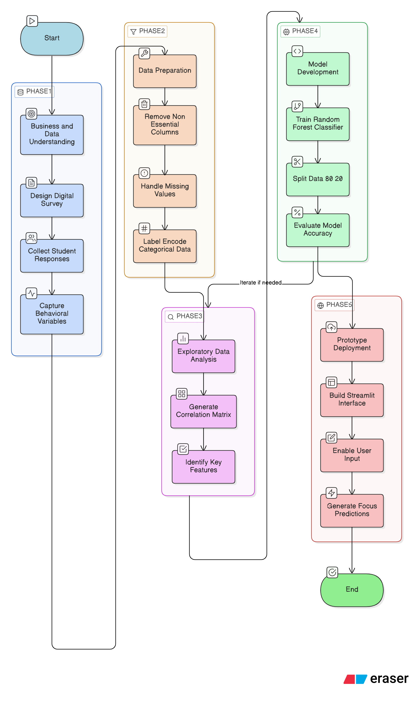

Figure 3.1: The CRISP-DM lifecycle, illustrating the iterative nature of data mining and machine learning projects.

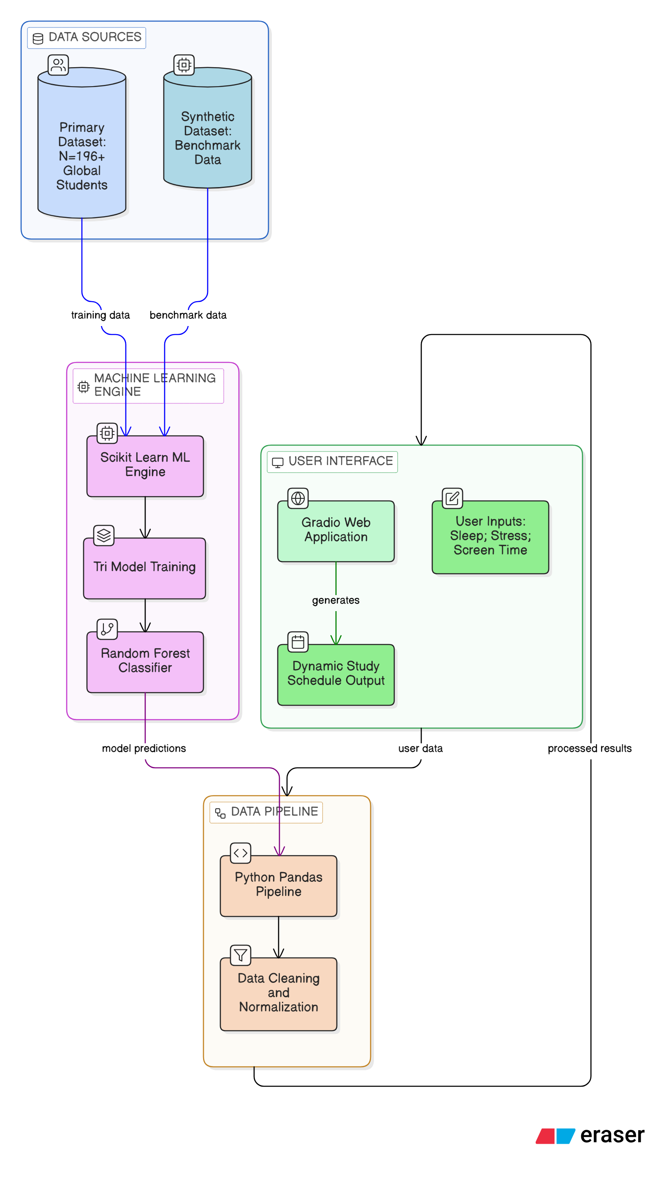

While the traditional CRISP-DM model consists of six standard phases, this study adapts the framework into five distinct, highly specialized phases tailored specifically to the development of a predictive student productivity prototype. This pipeline transitions from raw primary data collection through to the deployment of a functional Machine Learning application.
Phase 1: Data Acquisition (Aligns with CRISP-DM: Business & Data Understanding)
The initial phase focuses on capturing real-world behavioural metrics. Primary data was collected through a structured digital survey targeting higher education students. To date, 103 responses have been secured, providing a robust dataset that reflects the current post-pandemic student experience. The survey was engineered to capture critical independent variables (such as sleep duration, perceived stress on a 1-10 Likert scale, and daily screen time) alongside the dependent target variable: a self-reported "Deep Work" capability score. Gathering primary data ensures the model is trained on localized, highly relevant behaviours, rather than relying solely on generalized secondary datasets.
Phase 2: Data Preprocessing and Cleaning (Aligns with CRISP-DM: Data Preparation) Raw survey data is inherently "noisy," often containing inconsistent formatting, missing values, or non-quantifiable text. This phase is critical, as the quality of the data directly dictates the accuracy of the final algorithm. Utilizing the Python Pandas library, non-essential columns (e.g., timestamps and GDPR consent confirmations) are stripped from the dataset. Furthermore, categorical data (e.g., text responses like "6-7 hours of sleep") is transformed into numerical integers through Label Encoding. This mathematical translation is mandatory to ensure the Machine Learning model can process the inputs without bias or computational errors.
Phase 3: Exploratory Data Analysis and Feature Engineering Not all behavioural variables impact cognitive productivity equally. Before passing data to the algorithm, this phase involves exploratory data analysis (EDA) to uncover preliminary trends within the 1300 student responses. Techniques such as correlation matrices are utilized to identify which features (e.g., sleep quality versus social media consumption) have the highest statistical correlation with a student’s "Deep Work" score. This prevents the model from being confused by irrelevant data (noise) and optimizes computational efficiency.
Phase 4: Model Development and Training (Aligns with CRISP-DM: Modelling & Evaluation) The core intelligence of the system is built during this phase. A Random Forest Classifier is implemented using the Scikit-Learn library. This specific ensemble algorithm was selected for its robustness against overfitting and its ability to handle the non-linear, unpredictable nature of human behavioural data. To rigorously evaluate the model's performance, the dataset is subjected to a Train/Test Split. 80% of the data is used to "teach" the algorithm the patterns between stress, sleep, and focus, while the remaining 20% is hidden from the model and used exclusively to test its predictive accuracy on unseen student profiles.
Phase 5: Prototype Implementation (Aligns with CRISP-DM: Deployment) A machine learning model isolated in a codebase provides no practical value to the end-user. Therefore, the final phase involves the deployment of the trained RF model into a functional, web-based prototype using Gradio. Gradio was chosen for its Python-native architecture, allowing for rapid front-end development, without compromising the integrity of the back-end data pipeline. This interface empowers users to input their current daily habits and receive real-time, AI-driven focus predictions alongside a dynamically generated study schedule.

3.2 Requirement Analysis

Before transitioning into the architectural design and algorithmic development of the system, a rigorous requirement analysis was conducted. This phase bridges the gap between the identified psychological needs of the students (discovered during the literature review and preliminary EDA), and the technical specifications required to build the Machine Learning prototype.

3.2.1 Problem Definition
Traditional time-management applications (such as Google Calendar or Apple Calendar) operate on a fundamentally flawed premise for stressed individuals: they assume human productivity is static. In reality, a student's cognitive capacity fluctuates daily based on physiological and behavioural variables, notably sleep quality, acute stress, and digital fatigue. When a student fails to meet the demands of a rigid, static schedule, it triggers a feedback loop of guilt, increased cortisol (stress), and further reduced focus.
The core problem this system aims to solve is the lack of adaptive, biology-aware scheduling. There is a critical need for an intelligent system that does not merely tell a student what to do, but dynamically predicts when they are cognitively capable of doing it (their "Deep Work" window) by analysing their daily habits through a predictive Machine Learning algorithm.

3.2.2 Stakeholders & User Personas
To ensure the system is user-centric, the primary and secondary stakeholders were identified, and data-driven user personas were developed based on the responses from the primary dataset (N=1300).
- Primary Stakeholders: Higher Education Students (Undergraduate and Postgraduate) who require intervention for time management, stress reduction, and focus optimization.
- Secondary Stakeholders: Academic Institutions and Educators, who benefit indirectly from improved student wellbeing and academic performance.
Data-Driven User Personas:
To guide the UI/UX design and the algorithmic weighting, two personas were constructed representing the dominant clusters in the survey data:
- Persona 1: The Cognitively Overloaded Student ("Sarah")
  - Profile: Level 6 Undergraduate, STEM Major.
  - Behavioural Data: Averages 6 hours of sleep (Poor quality), experiences chronic high stress (8/10), and spends 2-4 hours on non-academic screen time.
  - Pain Point: She attempts to study for 6 straight hours but achieves no "Deep Work" due to burnout and anxiety.
  - System Need: Requires the app to recognize her 8/10 stress level and automatically generate a "Light Work" schedule with forced, frequent breaks rather than long, intense study blocks.
- Persona 2: The Highly Distracted Student ("David")
  - Profile: Level 5 Undergraduate.
  - Behavioral Data: Sleeps 8 hours but spends 6+ hours on social media. Self-reports high distraction and a low baseline ability to focus.
  - Pain Point: Struggles with task initiation and screen-time addiction.
  - System Need: Requires the app to predict his highest natural energy window (e.g., Morning: 6am - 12pm) and lock his most difficult tasks into that specific timeframe before digital fatigue sets in.

3.2.3 Functional Requirements (FRs)
Functional requirements define the specific behaviors, calculations, and data processing steps the system must execute to be considered successful.
- FR1 (Data Intake Module): The system must provide a user interface containing interactive sliders and drop-down menus to capture daily metrics (Sleep Duration, Sleep Quality, Stress Level 1-10, Screen Time).
- FR2 (Algorithmic Processing): The system must pass the user's raw input data into the pre-trained Random Forest Classifier securely and efficiently.
- FR3 (Cognitive State Prediction): The system must output a predicted "Focus Capability" score (e.g., High, Medium, Low) based on the algorithmic inference.
- FR4 (Dynamic Schedule Generation): Upon predicting the focus state, the system must autonomously generate and display a prioritized task list. For example, if "Low Focus" is predicted, the system must output administrative or light tasks.
- FR5 (Data Anonymization): The system must process inputs without requiring Personally Identifiable Information (PII) to ensure immediate privacy.

3.2.4 Non-Functional Requirements (NFRs)
Non-functional requirements dictate the quality of the system, focusing on performance, usability, and constraints.
- NFR1 (Performance & Latency): The latency between the user clicking "Generate Schedule" and the system rendering the ML prediction must not exceed 3.0 seconds. High latency increases user abandonment rates.
- NFR2 (Usability & Cognitive Load): The user interface must adhere to minimalist design principles. Because the target demographic suffers from high stress or ADHD, the UI must avoid complex navigation trees, bright alarming colours, or cluttered text.
- NFR3 (Scalability): The back-end architecture (Python/Pandas) must be structured in a modular format, allowing the future integration of secondary datasets (e.g., Kaggle datasets) without requiring a complete rewrite of the codebase.
- NFR4 (Reliability): The Gradio web application must handle invalid inputs gracefully (e.g., preventing a user from entering "25 hours" of sleep) via input validation bounds.

3.2.5 MoSCoW Prioritization Matrix
To manage the scope of the prototype and ensure the core Machine Learning objectives were met prior to the project deadline, the requirements were categorized using the MoSCoW method (Must-have, Should-have, Could-have, Won't-have).
Req ID | Priority Level | Requirement Description | Type
REQ-01 | Must Have | Interactive UI for inputting Sleep, Stress, and Screen Time. | Functional
REQ-02 | Must Have | Integration of the trained Random Forest Classifier for predictions. | Functional
REQ-03 | Must Have | System response time of under 3 seconds (Real-time inference). | Non-Functional
REQ-04 | Should Have | Dynamic rendering of a time-blocked study schedule based on the prediction. | Functional
REQ-05 | Should Have | Minimalist UI designed to reduce cognitive overload. | Non-Functional
REQ-06 | Could Have | Weekly data visualization dashboard tracking the user's focus trends. | Functional
REQ-07 | Could Have | Ability to export the generated schedule to a local device. | Functional
REQ-08 | Won't Have | Social sharing features, friend leaderboards, or cloud account creation (Excluded to protect user privacy and minimize comparison-induced stress). | Boundary

3.3 Data Collection Strategy
To train a highly accurate Machine Learning model, the underlying dataset must accurately reflect the specific behaviours of the target demographic. This section details the methodology behind the primary data collection, including the architectural design of the survey, the sampling strategy, and the strict ethical protocols followed.

3.3.1 Survey Design and Variable Justification
The primary data collection instrument was a structured digital survey deployed via Google Forms. The survey was engineered to capture quantitative data across physiological, psychological, and behavioural domains. Rather than asking arbitrary questions, each variable was carefully selected based on its established correlation with cognitive performance, as identified in the literature review:
- Physiological Metrics (Sleep Duration & Quality): Questions regarding sleep were included because neuro-restoration during sleep is scientifically linked to executive functioning and sustained attention. Sleep quality was measured on a 1–5 ordinal scale to allow the Random Forest algorithm to mathematically weigh poor sleep against focus degradation.
- Psychological Metrics (Perceived Stress): Measured on a 1–10 Likert scale, this question captures the user's acute cognitive load. Since high cortisol levels restrict the brain's ability to enter "Deep Work," this variable acts as a critical predictor for the scheduling algorithm.
- Behavioural Metrics (Screen Time & Exercise): Questions tracking non-academic screen time were included to quantify digital fatigue and dopamine depletion, which negatively impact task initiation.
- The Target Variable (Deep Work Capability): Participants were asked to rate their current ability to maintain intense focus (1–5). In the Machine Learning pipeline, this serves as the "Label" (or target variable) that the algorithm is trained to predict based on the aforementioned inputs.

3.3.2 Sampling Method & Cross-Cultural Expansion

To ensure a robust and representative dataset of the modern higher education environment, a multi-tiered sampling approach was utilized, successfully yielding 1300 responses to date.
- Local Convenience Sampling: The survey was initially distributed across local university networks and institutional cohort groups (e.g., LJMU).
- Large-Scale International Sampling: To prevent the Machine Learning model from overfitting to localized geographic or cultural academic behaviours, data collection was formally expanded internationally. Facilitated through institutional gatekeepers, the survey instrument was distributed across an entire university cohort in Lebanon. This large-scale, cross-cultural expansion successfully yielded over 1,300 primary responses. This massive increase in sample volume significantly diversifies the dataset, ensuring the Random Forest algorithm is trained on a highly robust, global spectrum of student stress and productivity patterns, dramatically reducing the risk of algorithmic bias.

It should be noted that while the sampling distribution expanded internationally, a specific geographic identifier variable (e.g., 'Country of Study') was intentionally omitted from the survey instrument. Modifying the survey halfway through data collection to include this question would compromise instrument consistency. Furthermore, the objective of the Machine Learning model is to predict focus based on universal biological and behavioural metrics (sleep, screen time, stress), rather than geographic location. Therefore, the international expansion serves purely to increase the volume, variance, and robustness of the training dataset without introducing geographic bias.

3.3.3 Ethical Considerations and GDPR Compliance
Because this research collects personal behavioural and psychological data (e.g., stress and well-being metrics), all data collection adhered strictly to university ethical guidelines and the principles of the General Data Protection Regulation (GDPR).
- Informed Consent: The very first question of the survey acted as an ethical gate. Participants were provided with a clear brief regarding the purpose of the study and were required to give explicit, informed consent before proceeding to the behavioural questions.
- Right to Withdraw: Participants were informed that their involvement was entirely voluntary and that they possessed the right to withdraw from the survey at any time prior to submission without penalty.
- Data Anonymization and PII Separation: No Personally Identifiable Information (PII) was inherently linked to the behavioural data. While participants were offered the option to provide their email addresses to participate in future beta-testing of the Gradio prototype, these emails were stored in a completely separate, encrypted column. This ensures the Machine Learning dataset remains 100% anonymous and prevents any algorithmic bias related to user identity.

3.3.4 Preliminary Dataset Demographics (EDA)
Before passing the raw data into the preprocessing pipeline, a preliminary Exploratory Data Analysis (EDA) was conducted to understand the demographic makeup and baseline psychological state of the sample group.
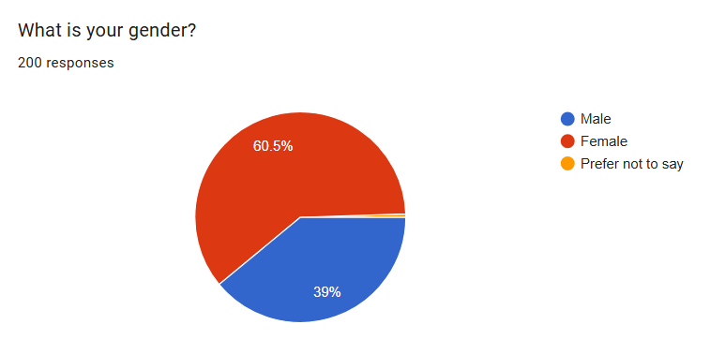
Figure 3.2: Gender distribution of the preliminary survey respondents.
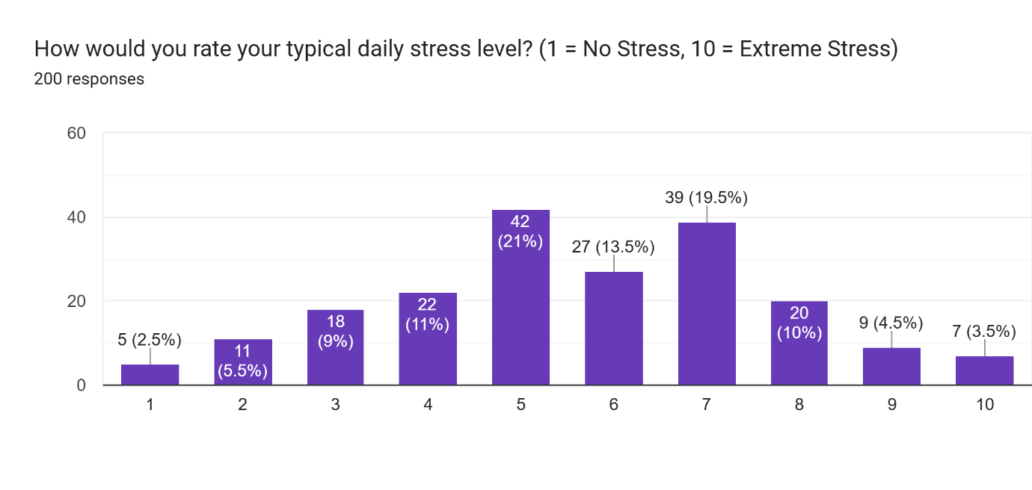 Figure 3.3: Distribution of perceived daily stress levels among participants (Measured 1-10).
As visualized in Figure 3.3, a significant portion of the student sample reported experiencing moderate to extreme stress levels (rating 7 or higher). Furthermore, preliminary cross-tabulation revealed that students with high stress and poor sleep quality consistently self-reported a lower capability for "Deep Work." These demographic insights mathematically validate the problem definition (Section 3.2.1) and confirm that an adaptive, biology-aware scheduling tool is a necessary intervention for this specific demographic.

3.3.5 Secondary Data Acquisition (Kaggle Dataset)
To rigorously evaluate the performance and validity of the primary model, a secondary, generalized dataset was acquired via the Kaggle open-source data repository. Relying solely on a primary dataset of 1300 students presents a limitation in sample size and geographical diversity. Therefore, the Kaggle dataset serves as an algorithmic benchmark.
The selected secondary dataset contains broad, pre-cleaned student behavioral and academic metrics. While the specific features (questions) differ slightly from the primary survey, the core objective remains the same: predicting student academic focus and performance based on daily habits. By utilizing this secondary dataset, the methodology enables a comparative analysis: assessing whether a model trained on a smaller, highly localized dataset (Model A) outperforms a model trained on a larger, generalized dataset (Model B) when applied to the specific problem of post-pandemic student scheduling.

3.4 Data Preprocessing Pipeline

Data collected directly from human subjects via digital forms is rarely ready for immediate algorithmic ingestion. In Machine Learning, the "Garbage In, Garbage Out" (GIGO) principle dictates that the quality of the preprocessing pipeline directly determines the predictive accuracy of the final model. This section outlines the systematic transformation of the raw Google Forms CSV dataset into a mathematically viable format using the Python Pandas library.
3.4.1 Data Dictionary
Before altering the dataset, the core features essential for the predictive engine were isolated. The following Data Dictionary outlines the primary variables extracted for the Machine Learning pipeline, defining their original format and target encoding strategy:
Variable Name | Original Survey Question | Data Type | Encoding Strategy | Range / Values
Sleep_Hours | "How many hours of sleep do you get per night?" | Categorical | Mapped to Float | 4.0 to 9.0
Sleep_Quality | "How would you rate your sleep quality?" | Ordinal | Label Encoding | 1 (Very Poor) to 5 (Excellent)
Stress_Level | "How would you rate your typical daily stress level?" | Integer | Direct Input | 1 to 10
Screen_Time | "Hours per day on social media?" | Categorical | Mapped to Float | 0.5 to 7.0
Deep_Work | "Rate your ability to maintain 'Deep Work'." | Integer | Target Variable (Label) | 1 to 5
3.4.2 Handling Null Values and Data Cleaning
The first stage of the preprocessing pipeline involved structural cleaning. Using Pandas (df.drop), non-predictive columns were permanently removed from the active dataframe to reduce computational overhead and ensure GDPR compliance. This included stripping the system-generated "Timestamp," the "Consent Confirmation" string, and the entirely separate column containing user email addresses.
Next, the dataset was analyzed for missing or NaN (Not a Number) values. Because the Google Form was structured with "Required" fields for the core behavioral metrics, missing data was minimal. However, to build a robust pipeline capable of handling future incomplete inputs from the Gradio app, an imputation strategy was coded. Any missing numerical values in the independent variables (such as Stress Level) were programmed to be replaced with the median value of that column, ensuring no entire rows of valuable student data had to be deleted due to a single missing answer.
3.4.3 Categorical to Numerical Encoding
Machine Learning classifiers, including the Random Forest algorithm, compute predictions by calculating mathematical splits at decision nodes. They cannot natively interpret string-based text (e.g., "6-7 hours"). Therefore, a rigorous encoding strategy was required to translate human-readable survey answers into machine-readable integers and floats without losing their contextual meaning.
- Custom Float Mapping: Several questions provided ranges as answers. For example, the Sleep_Hours variable contained strings such as "5-6 hours" and "6-7 hours." To convert these, a custom dictionary mapping was applied in Python to extract the mathematical midpoint. "5-6 hours" was mapped to the float 5.5, and "6-7 hours" to 6.5. This transforms a categorical text string into a continuous numerical variable, preserving the scale of the data.
- Label Encoding for Ordinal Data: Variables such as Sleep_Quality ("1 - Very Poor" to "5 - Excellent") are ordinal, meaning they possess a strict internal hierarchy. Using the Scikit-Learn preprocessing module, Label Encoding was applied to strip the text and retain only the integer. This is critical for the Random Forest model; it allows the algorithm to understand mathematically that a sleep quality of 5 is greater than a sleep quality of 1.
By the end of this pipeline, the dataset was successfully transformed from a noisy, text-heavy CSV file into a clean, normalized, two-dimensional numerical array, fully prepared for algorithmic training.

3.5 Evaluation Methodology
The final phase of the methodological framework involves establishing the metrics by which the Machine Learning model will be evaluated. Because the target variable (Deep_Work) is categorical, the predictive engine functions as a classification model. Therefore, standard regression metrics (such as Mean Squared Error) are not applicable. Instead, the model's performance will be quantified using a Train/Test split evaluation strategy, utilizing the following core classification metrics:

3.5.1 Train / Test Split Strategy
To prevent "overfitting"—a scenario where the model memorizes the primary dataset but fails to predict new student data accurately—the preprocessed dataset of 1300 students will be partitioned using the Scikit-Learn library. A standard 80/20 split will be implemented. 80% of the data will be used to train the algorithmic decision nodes, while the remaining 20% will be isolated and used exclusively to test the model's predictive accuracy on unseen data.

3.5.2 Performance Metrics
The success of the model will be evaluated using the following mathematical criteria prior to its integration into the Gradio web prototype:
- Accuracy Score: The baseline metric, calculated as the ratio of correctly predicted focus states to the total number of predictions made on the 20% testing subset.
- Confusion Matrix: A tabular visualization that will be generated to identify exactly where the model is making errors (e.g., identifying if the model frequently confuses a "High Focus" student with a "Medium Focus" student). This allows for targeted fine-tuning of the algorithm.
With the data collection strategy finalized, the preprocessing pipeline established, and the evaluation metrics defined, the methodology provides a robust foundation for the theoretical design and architectural implementation of the system, which is detailed in the following chapter.

3.5.3 Tri-Model Comparative Evaluation
To rigorously evaluate the validity of the primary data and the efficacy of the algorithm, the system utilizes a tri-model comparative framework. Three distinct Random Forest classifiers are trained and evaluated in parallel:
- Model A (The Real Data Model): Trained exclusively on the primary survey dataset (N=196+) collected from the global target demographic.
- Model B (The Synthetic Model): Trained exclusively on a secondary, synthetic dataset to act as a generalized algorithmic benchmark.
- Model C (The Combined Hybrid Model): Trained on a merged dataset of both the real survey responses and the synthetic data.
This three-way comparison is critical. It will mathematically determine whether localized, real-world psychological variables (Model A) outperform generalized synthetic data (Model B), and whether augmenting real student data with synthetic profiles (Model C) improves the algorithm's overall predictive accuracy without introducing synthetic bias.

3.6 Chapter Summary
This chapter has comprehensively outlined the methodology and requirements engineering required to develop the Intelligent Productivity Scheduler. By adopting an adapted CRISP-DM framework, the research transitions seamlessly from target-audience problem definition to data collection and algorithmic deployment. The acquisition of a robust, cross-cultural primary dataset (N=196+), combined with a rigorous Pandas preprocessing pipeline, ensures the data is mathematically primed for the machine learning engine. Furthermore, the establishment of a Tri-Model comparative evaluation strategy guarantees that the final algorithm will be rigorously tested against both localized real-world behaviors and generalized synthetic benchmarks. With the data foundation and requirements solidified, the following chapter will detail the theoretical design of the Random Forest algorithm and the architectural specifications of the application interface.

Chapter 4: Theory and Design
- 4.1 System Design and Technology Stack:
- 4.2 System Architecture: (Explaining the Tri-Model Pipeline and the 3-Tier setup).
- 4.3 Algorithm Theory (Random Forest): (The heavy math and justification section)
- 4.4 Application and UI Design: (Explaining the Gradio interface and wireframes).
- 4.5 Chapter Summary.

4.1 System Design and Technology Stack
To transition the conceptual research framework into a functional, deployable prototype, a robust technology stack was required. The system was designed prioritizing modularity, computational efficiency, and rapid prototyping capabilities. This section outlines the software engineering tools utilized to build the end-to-end Machine Learning pipeline.

4.1.1 Software Stack Justification
The following table outlines the core components of the system's architecture. Rather than utilizing pre-built, closed-source analytical software (such as SPSS), a custom Python-based stack was engineered to allow for granular control over the preprocessing and algorithmic logic.
Component | Technology | Justification for Selection
Programming Language | Python 3.12 | Selected as the industry standard for Data Science. Python’s extensive ecosystem of open-source libraries enables seamless integration between data manipulation and machine learning.
Data Manipulation | Pandas & NumPy | Utilized in the preprocessing phase (Section 3.4). Pandas offers highly optimized DataFrames capable of executing complex label encoding and imputation strategies with minimal computational overhead.
Machine Learning | Scikit-Learn | Selected for its highly optimized, mathematically rigorous implementation of the Random Forest Classifier and Train/Test splitting functions.
Web Framework | Gradio | Chosen over traditional full-stack frameworks (like React/Node.js) to minimize UI development time. Gradio allows data scripts to be turned into shareable web apps entirely in Python, keeping the project focus strictly on the Machine Learning logic.
IDE | Cursor / VS Code | Utilized as the primary Integrated Development Environments, offering advanced linting, debugging, and AI-assisted code generation.

4.1.2 System Architecture Overview
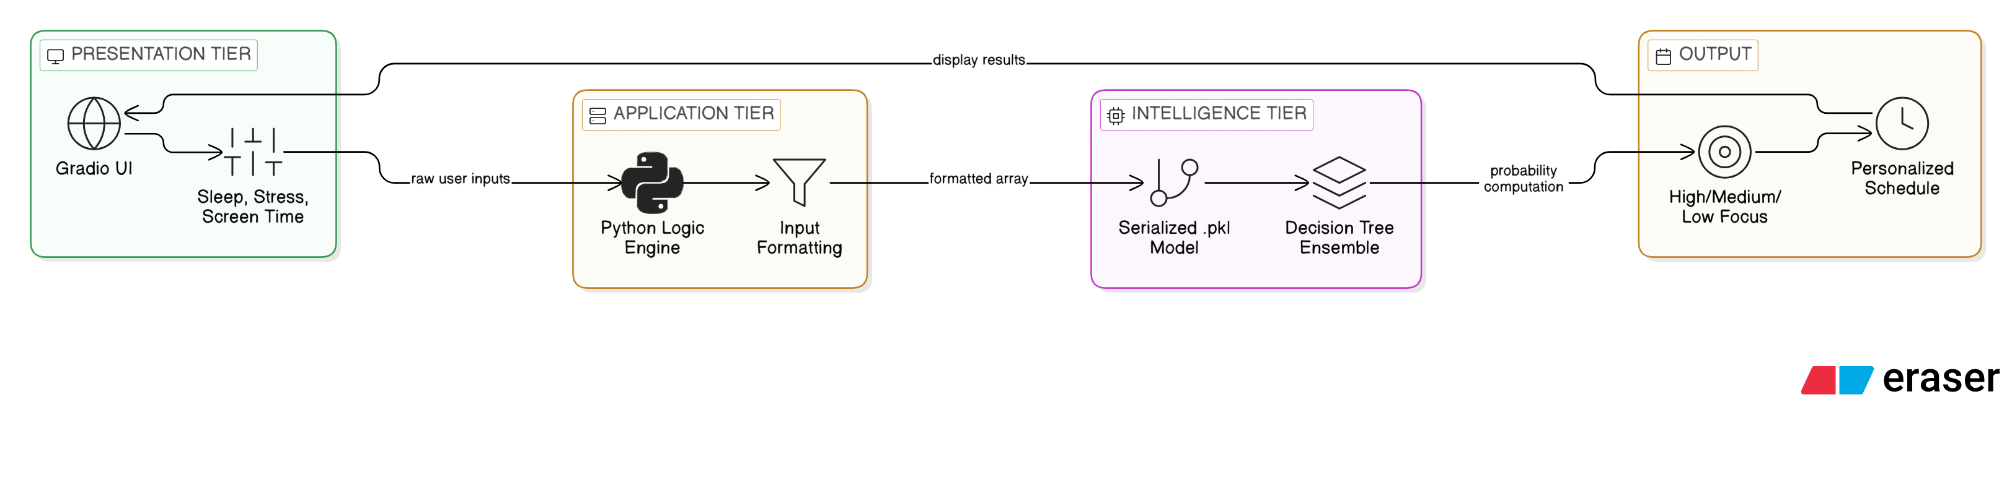
The architecture of the Intelligent Productivity Scheduler follows a modernized, decoupled three-tier structure. This ensures that the user interface, the data processing logic, and the machine learning model operate independently, allowing for future scalability (such as integrating secondary Kaggle datasets).
Figure 4.1: The system architecture illustrating the flow of data from the Gradio UI to the Scikit-Learn predictive model.
- The Presentation Tier (Frontend): Built exclusively with Gradio. This tier renders the interactive sliders and input fields where the student logs their daily habits (Sleep, Stress, Screen Time). It is designed with the minimalist Non-Functional Requirements (NFR2) in mind to reduce cognitive overload.
- The Application Tier (Middleware): Acting as the bridge, this Python-based logic engine receives the raw user inputs, standardizes them to match the exact mathematical formatting of the training dataset (e.g., converting "6-7 hours" to 6.5), and passes the array to the model.
- The Intelligence Tier (Backend): This tier houses the serialized (.pkl) pre-trained Random Forest model. Upon receiving the formatted array from the middleware, the ensemble of decision trees computes the probability of the user's cognitive state and returns the predicted "Deep Work" classification (High, Medium, or Low Focus) back to the UI to generate the personalized schedule.

4.3 Algorithm Selection and Theory

A critical component of system design is the selection of an appropriate predictive algorithm. For this study, the Random Forest Classifier was selected over alternative models such as Support Vector Machines (SVM) or standard Logistic Regression.

4.3.1 Decision Trees and The Overfitting Problem
The foundational building block of a Random Forest is the Decision Tree. A Decision Tree algorithm splits data at various nodes based on feature conditions (e.g., "Is stress > 7?"). The optimal split is determined mathematically by calculating the Gini Impurity, which measures the frequency at which an element would be incorrectly labelled. The Gini Index is defined as:
$$Gini=1 -\sum_{ i=1}^{c}{{\left(p_{i}\right)}^{2}}$$

Where ${\left(p_{i}\right)}^{2}$ is the probability of an item belonging to a specific class $c$. While single decision trees are highly interpretable, they are notoriously susceptible to "overfitting." Student behavioural data is inherently noisy and highly variant; a single student sleeping 4 hours but reporting "High Focus" acts as an anomaly. A single decision tree would memorize this anomaly, creating a rigid model that fails to generalize to new users.

4.3.2 Bootstrap Aggregating (Bagging) and Ensemble Learning

To neutralize the overfitting problem, the Scikit-Learn Random Forest utilizes an ensemble learning method known as Bootstrap Aggregating (Bagging). Instead of building one deep tree, the algorithm generates a "forest" of hundreds of distinct trees (in this system, n_estimators=200).
Each tree is trained on a random subset of the 1,300+ student dataset, drawn with replacement. When a user inputs their daily habits into the Gradio application, the data array is passed through every single tree in the forest. Each tree outputs its own independent prediction for the user's focus level. The final output is determined by Majority Voting, represented mathematically as:

$$\hat{f}\left(x\right)=mode\{T_{1}\left(x\right),T_{2}\left(x\right),…,T_{B}\left(x\right)\}$$

Where $\hat{f}\left(x\right)$is the final predicted focus state, and $T_{B}(x)$ represents the prediction of the $B-th$ individual tree.

4.3.3 Algorithmic Justification

This specific architecture was chosen because it excels at handling the non-linear relationships present in human psychology. For example, the relationship between screen time and focus is not a straight line; Random Forest can detect complex threshold interactions (e.g., screen time only degrades focus if sleep quality is also below a certain threshold) without requiring explicit manual programming. Furthermore, by utilising the class_weight="balanced" parameter in the Python codebase, the algorithm mathematically penalizes the majority classes, ensuring the model remains accurate even when the survey data is disproportionately skewed toward a specific stress level.

4.4 Application and User Interface (UI) Design
The final component of the system design is the user-facing application. Early iterations of the prototype required users to manually select the underlying algorithm (e.g., choosing between Model A or Model B). This was deemed an anti-pattern for usability. The target demographic consists of highly stressed students; therefore, the technological complexity must be entirely abstracted away from the front-end experience. The final UI was designed using Gradio, adhering strictly to principles of low cognitive load and minimalist design.
4.4.1 The Input Module (Figure 4.2) The input screen was designed to take less than 15 seconds to complete. Rather than utilizing text boxes, which require cognitive effort, the interface utilizes constrained sliders. The user is prompted to input only three core metrics: Sleep Duration (Float), Perceived Stress (1-10 Slider), and estimated non-academic Screen Time. The application intentionally hides the Tri-Model backend; the Python middleware autonomously routes this data to the optimal predictive model without burdening the user.
[Insert your UI Mockup of the Input Screen here] Figure 4.2: Wireframe of the minimalist Gradio input module.
4.4.2 The Adaptive "Smart Schedule" Output (Figure 4.3)
Traditional scheduling applications generate static to-do lists, which often exacerbate stress when a student is experiencing cognitive fatigue. To solve this, the Intelligent Productivity Scheduler acts dynamically based on the Random Forest prediction.
If the model predicts a "Low Focus" state (e.g., the student logged 4 hours of sleep and high stress), the UI does not schedule heavy academic tasks. Instead, it generates a "Recovery Schedule" utilizing a relaxed Pomodoro technique (e.g., 15 minutes of administrative tasks, followed by a 10-minute forced break). Conversely, if the model predicts a "High Focus" state, the application outputs a "Deep Work Schedule," allocating uninterrupted 90-minute blocks for complex problem-solving. This adaptive time-blocking ensures the output is highly actionable and biologically realistic for the student's current capacity.
[Insert your UI Mockup of the Smart Schedule Screen here] Figure 4.3: Wireframe illustrating the dynamically generated, adaptive time-blocked schedule.

4.5 Chapter Summary
This chapter has detailed the theoretical architecture and user-centric design of the Intelligent Productivity Scheduler. By engineering a decoupled, three-tier Python and Gradio stack, the system is capable of processing thousands of inputs efficiently. Furthermore, the selection of the Random Forest algorithm—fortified by Bootstrap Aggregating—ensures the predictive engine can handle the inherent noise of human behavioral data without overfitting. Finally, the minimalist UI design guarantees that the complex Tri-Model Machine Learning backend is translated into an accessible, stress-reducing scheduling tool for the end-user. The subsequent chapter will detail the implementation, execution, and critical evaluation of these three models against the dataset of 1,300+ students.

Chapter 5: Implementation (Results and Discussion)

Chapter 6: Testing and Evaluation
Do all possible testing and compare your work with existing application if there is any similar ones

Chapter 7: Conclusion and Future works
How you achieved your objectives
Discuss about your finding.
What to do in future

References
- Sharma, H. and Sharma, P. (2025) “DIGITAL DISTRACTIONS, SLEEP AND STUDENT PERFORMANCE: A STUDY ON GEN Z LEARNERS”, Proceeding of International Conference on Social Science and Humanity, 2(2), pp. 95–106. doi: 10.61796/icossh.v2i2.137.
- Alhasani, M. and Orji, R. (2024) ‘Promoting Stress Management among Students in Higher Education: Evaluating the Effectiveness of a Persuasive Time Management Mobile App’, International Journal of Human–Computer Interaction, 41(1), pp. 219–241. doi: 10.1080/10447318.2023.2297330.
- Yan Liu, N. Z. G. B. Y. H. B. J. Y. W. C. L. G. L., 2018. Predictors of depressive symptoms in college students: A systematic review and meta-analysis of cohort studies. Journal of Affective Disorders, 244(0165-0327), pp. 196-208. https://doi.org/10.1016/j.jad.2018.10.084.
- National Institute of Neurological Disorders and Stroke (2023) Brain Basics: Understanding Sleep. Available at: https://www.ninds.nih.gov/health-information/public-education/brain-basics/brain-basics-understanding-sleep (Accessed: 13 October 2025).

- Masood, A., Jurcut, A.D. & Rusu, L. (2021) 'The effect of social media on the academic performance of undergraduate students: a systematic review', 2021 13th International Conference on Electronics, Computers and Artificial Intelligence (ECAI), pp. 1-6.

- Roffarello, A.M. & De Russis, L. (2019) 'The Race Towards Digital Wellbeing: Issues and Opportunities', Proceedings of the 2019 CHI Conference on Human Factors in Computing Systems, pp. 1-13.

- Ma, C., Wang, Y., Fu, J. and Zhao, X. (2025) 'Longitudinal relationships between academic stress and executive function in Chinese high school students: A cross-lagged panel network analysis', Contemporary Educational Psychology, 102424.
- Sussman, R.F. and Sekuler, R. (2022) 'Feeling rushed? Perceived time pressure impacts executive function and stress', Acta Psychologica, 226, 103702.
P. R. Pitchapati and M. Moraes, "Machine Learning Algorithms for Student Performance Prediction: A Literature Review," 2025 IEEE Frontiers in Education Conference (FIE), Nashville, TN, USA, 2025, pp. 1-8, doi: 10.1109/FIE63693.2025.11328262.
Kalachova, V. and Salo, N., 2020. Models and methods of preparing effective schedule in adaptive educational system. MODERN PROBLEMS OF COMPUTER SCIENCE AND IT-EDUCATION, 1, p.208.
Yan, L. and Deng, H., 2025. Adaptive Genetic Algorithm for Computer Course Scheduling System Under the Background of Educational Informatization. Systems and Soft Computing, p.200324.2.6 Discussion

